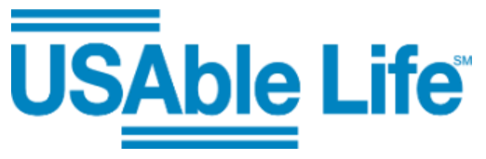

##### Employee Benefits Enrollment is February 6 - February 10, 2023

Below you can find a link with information about the products that USAble offers. Any elections made during enrollment will go in effect May 1st. First payroll deductions will be April 15th.

[http://group.usablelife.com/tn/sequatchie-county-schools](https://nam12.safelinks.protection.outlook.com/?url=http%3A%2F%2Fgroup.usablelife.com%2Ftn%2Fsequatchie-county-schools&data=05%7C01%7CRebecca.Coker%40usablelife.com%7Cae81d86a66ec4d379cba08dafb039258%7C1ecef9e1be2a46c88d6a6d7cd077c4f1%7C0%7C0%7C638098290002532517%7CUnknown%7CTWFpbGZsb3d8eyJWIjoiMC4wLjAwMDAiLCJQIjoiV2luMzIiLCJBTiI6Ik1haWwiLCJXVCI6Mn0%3D%7C3000%7C%7C%7C&sdata=OIOgkJDa3HmZOBlApi4ASXKDrCnXFf38XM%2FmwgwWf5w%3D&reserved=0)